**Rent a Car**

A Rent Car web application is an online platform that allows users to rent vehicles for short-term use, typically ranging from a few hours to several days. a Rent Car web app provides a convenient and efficient way for users to find, book, and manage rental vehicles for their transportation needs. It simplifies the rental process for both users and rental companies, enhancing the overall experience

**Requirements**

**Landing page(Home):**

-As shown in given image in landing page there must be navigation bar at top

- Just below of it Keep tag line of your store and images must be scrollable

-Just below of it you have to display your services as show in image

-just below of it you have to display your best selling product with images

-just below to it display any special offer

-At last create footer for web app and devide it into Four part as shown in image and display information

**About Section**

The "About Us" page of an Rent a Car typically provides visitors with information about the store's background, mission, values, and commitment to Rent a Car principles. Here's a breakdown of the information you might find on an "About Us" page for an Rent a Car In

About part you can display or view

**-Store Background**: This section may include details about when the store was established, its founders, and the inspiration behind starting the online fast food restaurant.

**-Mission Statement**: The mission statement outlines the core purpose and objectives of the online fast food restaurant.

**-Values and Philosophy**: This section articulates the values and principles that guide the operations and decision-making processes of the online fast food restaurant.

**-Commitment to Hygiene Standards**: The "About Us" page often emphasizes the store's dedication to maintain Hygiene.

- -**Team or Staff**: Introducing the team or staff members behind the organic store adds a personal touch and helps customers connect with the people behind the business.

-**Customer Service Commitment**: Organic stores often emphasize their dedication to providing excellent customer service and fostering positive relationships with customers.

**Testimonials or Reviews**: Including customer testimonials or reviews can help build trust and credibility with potential customers. Sharing positive experiences from satisfied customers reinforces the store's reputation for quality products and service.

**Contact Information**: The "About Us" page typically includes contact information, such as the store's address, phone number, email address, and links to social media profiles.

-**Google map location:**

**All Products**

Here's a list of common types of vehicles that users might find in a Rent a Car web app**.**

**Compact Cars**: Small and fuel-efficient cars suitable for city driving and short trips. Examples include Toyota Corolla, Honda Civic, and Ford Focus.

**Sedans**: Mid-size to full-size cars with comfortable seating and ample trunk space. Examples include Toyota Camry, Honda Accord, and Nissan Altima.

**SUVs (Sport Utility Vehicles)**: Larger vehicles with higher ground clearance, suitable for family trips or off-road driving. Examples include Toyota RAV4, Ford Escape, and Honda CR-V.

**Vans**: Vehicles with extended seating capacity, suitable for transporting larger groups of people or cargo. Examples include Dodge Grand Caravan, Chrysler Pacifica, and Toyota Sienna.

**Trucks**: Vehicles with open beds for transporting cargo or towing trailers. Examples include Ford F-150, Chevrolet Silverado, and Toyota Tacoma.

**Luxury Cars**: High-end vehicles with premium features and luxurious interiors. Examples include BMW 5 Series, Mercedes-Benz E-Class, and Audi A6.

**Convertibles**: Cars with retractable roofs, perfect for enjoying open-air driving in warm weather. Examples include Ford Mustang Convertible, Chevrolet Camaro Convertible, and Mazda MX-5 Miata.

**Electric Cars (EVs) and Hybrids**: Environmentally-friendly vehicles with electric or hybrid powertrains, offering improved fuel efficiency and lower emissions.

**Sports Cars**: High-performance vehicles designed for speed and agility, ideal for enthusiasts or special occasions. Examples include Chevrolet Corvette, Porsche 911, and Ford Mustang GT.

**Motorcycles**: Two-wheeled vehicles suitable for solo riders or passengers, offering a fun and adventurous way to explore the open road. Examples include Harley-Davidson, BMW Motorrad, and Honda Gold Wing.

**Display product as shown below**

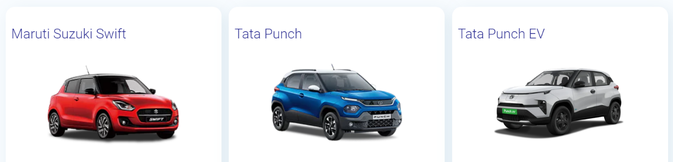

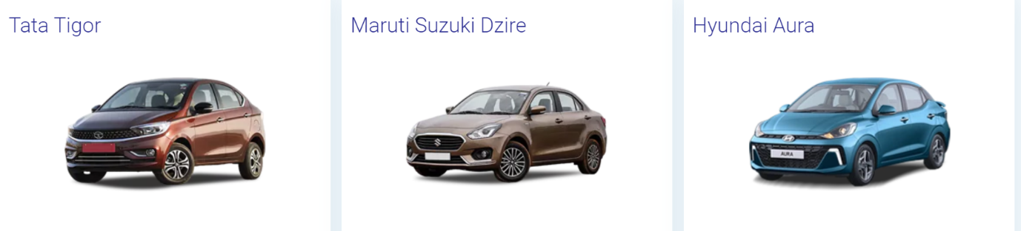

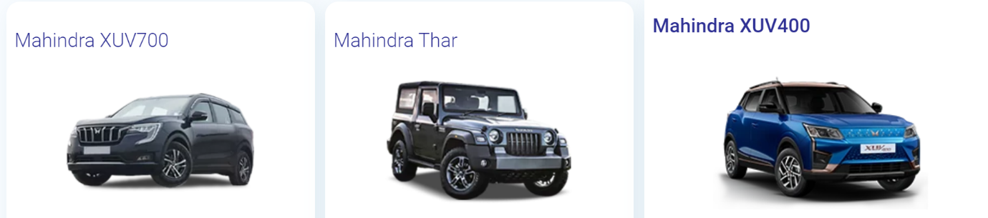

**users must log in before making purchases, you'll need certain requirements to ensure a smooth and secure shopping experience.**

**-** Here's a list of requirements:

**-User Authentication System**: Implement a user authentication system that allows users to register, log in, and manage their accounts securely. This system should include features such as userid, password, email, and more .

- **User Registration**: Provide a user registration form where new users can sign up for an account by providing their email address, username, and password. Optionally, you can include additional fields like name, address, and phone number.

- **Login Page**: Create a login page where registered users can log in using their email address or username and password.

- **Session Management**: Implement session management to keep track of user authentication status throughout their browsing session. This ensures that users remain logged in as they navigate the site and add items to their shopping cart.

**Vehicle Selection**: The app provides a catalog of available vehicles for rent, including cars, trucks, vans, SUVs, and specialty vehicles. Users can filter vehicles based on criteria such as vehicle type, make, model, transmission type, fuel efficiency, and seating capacity.

**User Profile Management**: Users can manage their profiles, update personal information, and view their rental history. This includes past and upcoming bookings, invoices, receipts, and any loyalty rewards or discounts earned through the app.

**Booking and Reservation**: Users can browse available rental dates and times, select their desired vehicle, and make a reservation. The app should display rental rates, rental duration options (e.g., hourly, daily, weekly), and any applicable fees or taxes. Users can choose pickup and drop-off locations and select any additional options or services (e.g., insurance coverage, GPS navigation systems, child seats).

**Customer Support**: The app offers customer support features such as live chat, email support, or a hotline for users to contact customer service representatives with questions, concerns, or assistance with bookings.

**Reviews and Ratings**: Users can leave reviews and ratings for rental vehicles and their overall rental experience. This feedback can help other users make informed decisions when choosing vehicles and rental locations.

**the admin plays a crucial role in managing various aspects of the website or application. Here are the key responsibilities of the admin**

**Admin Dashboard**: A backend dashboard allows administrators to manage vehicle inventory, rental bookings, user accounts, payments, and other aspects of the platform. Admins can track rental activity, generate reports, and make adjustments to rental rates or availability as needed.

**-Car Management**:

* Adding new products to the inventory.
* Updating product descriptions, prices, and images.
* Removing discontinued or out-of-stock products.
* Categorizing products into appropriate categories and subcategories.
* Managing product attributes such as sizes, colors, and variations.

- **Car Booking Management**:

* Monitoring and processing incoming orders.
* Updating order status (e.g., processing, shipped, delivered).
* Handling order cancellations, returns, and refunds.
* Generating invoices and packing slips for orders.
* Communicating with customers regarding order status and inquiries.

- **User Management**:

* Managing user accounts, including creating new accounts, editing profiles, and deleting accounts if necessary.
* Monitoring user activity, such as login attempts and order history.
* Handling user inquiries, feedback, and complaints.
* Implementing and enforcing user policies, such as terms of service and privacy policies.

- **Content Management**:

* Updating website content, including text, images, banners, and promotional materials.
* Managing blog posts, news articles, or other informational content.
* Ensuring that all content complies with legal and regulatory requirements

**Entity-Relationship (ER) diagram for a Rent a Car web application involving users, car booking, admin, reservation, cancellation, and availability. Here's a simplified ER diagram**

**Entities**:

1. User
2. Car
3. Booking
4. Admin
5. Reservation
6. Cancellation
7. Availability

**Relationships**:

1. A user can make zero or more bookings.
2. A booking must be made by exactly one user.
3. A booking is associated with exactly one car.
4. A car can be associated with zero or more bookings.
5. An admin manages zero or more bookings.
6. A booking is managed by exactly one admin.
7. A user can make zero or more reservations.
8. A reservation must be made by exactly one user.
9. A reservation is associated with exactly one car.
10. A car can be associated with zero or more reservations.
11. A booking can have zero or more cancellations.
12. A cancellation is associated with exactly one booking.
13. A car has availability information.
14. **Attributes**:
    1. User:
       1. User_ID (Primary Key)
       2. Username
       3. Email
       4. Password
       5. Address
       6. Phone_Number
    2. Car:
       1. Car_ID (Primary Key)
       2. Brand
       3. Model
       4. Year
       5. License_Plate
       6. Availability_Status
    3. Booking:
       1. Booking_ID (Primary Key)
       2. User_ID (Foreign Key referencing User)
       3. Car_ID (Foreign Key referencing Car)
       4. Booking_Date
       5. Pickup_Date
       6. Return_Date
       7. Total_Price
    4. Admin:
       1. Admin_ID (Primary Key)
       2. Username
       3. Email
       4. Password
    5. Reservation:
       1. Reservation_ID (Primary Key)
       2. User_ID (Foreign Key referencing User)
       3. Car_ID (Foreign Key referencing Car)
       4. Reservation_Date
       5. Pickup_Date
       6. Return_Date
    6. Cancellation:
       1. Cancellation_ID (Primary Key)
       2. Booking_ID (Foreign Key referencing Booking)
       3. Cancellation_Date
       4. Reason
    7. Availability:
       1. Car_ID (Primary Key, Foreign Key referencing Car)
       2. Pickup_Date
       3. Return_Date
       4. Available_Quantity

Here's the ER diagram:

**+-----------+ +-------------+ +-------------+**

**| User | | Car | | Booking |**

**+-----------+ +-------------+ +-------------+**

**| User_ID | | Car_ID | | Booking_ID |**

**| Username | | Brand | | User_ID |**

**| Email | | Model | | Car_ID |**

**| Password | | Year | | Booking_Date|**

**| Address | | License_Plate | | Pickup_Date |**

**| Phone_Num | | Availability_Status | | Return_Date |**

**+-----------+ +-------------+ | Total_Price |**

**| +-------------+**

**| 1 |**

**| |**

**+--------------+ |**

**| Admin | |**

**+--------------+ |**

**| Admin_ID | |**

**| Username | |**

**| Email | |**

**| Password | |**

**+--------------+ |**

**| |**

**| 1 |**

**| |**

**+-------------------+--------------------+**

**| Reservation |**

**+-------------------+**

**| Reservation_ID |**

**| User_ID |**

**| Car_ID |**

**| Reservation_Date |**

**| Pickup_Date |**

**| Return_Date |**

**+-------------------+**

**|**

**| 1**

**|**

**+-------------------+**

**| Cancellation |**

**+-------------------+**

**| Cancellation_ID |**

**| Booking_ID |**

**| Cancellation_Date |**

**| Reason |**

**+-------------------+**

**|**

**| 1**

**|**

**+-------------------+**

**| Availability |**

**+-------------------+**

**| Car_ID |**

**| Pickup_Date |**

**| Return_Date |**

**| Available_Quantity|**

**+-------------------+**